**Passive Valves Version 4** R Benedict, 3/31/2020

Overall

The valves are designed to fit into PVC Ts. They use a flat poppet that closes on a rubber washer commonly used for garden hoses. I tried to make the throat as large as possible to not restrict low pressure air flow when opened. The previous valves were weight loaded which I think do not require calibration since plastic density and nut weights are fairly repeatable. After requirements changed the new higher pressure valves are spring loaded and screw adjustable. Another advantage of weight load is that the pressure to lift the poppet does not change as the poppet rises, unlike spring valves which require ever more force to open wider. This allows a larger opening after cracking pressure that I think is useful for the AA valve.

AA

A main goal was to have this open at very low pressures and provide maximum flow. This gravity loaded valve must be mounted pointing down. The cracking pressure can be adjusted by adding more weight (nuts) to the poppet stem.

If this isn’t suitable a spring can be used, but I found it difficult to get the same intake with a spring.

OP and PEEP

These higher pressure valves are spring loaded and screw adjustable. While that allows a far greater opening range and pressure, I think that they will require local calibration. COTS springs have great variability from different sources and must be cut to length which introduces another variability. A benefit of the spring design is that you can use one body for both OP and PEEP. The only difference is that you use a longer spring to get some preload for the higher OP pressure open. In either case you can adjust the opening pressure by turning the screw. I used a spring that is 10 mm long for the PEEP and 15 mm for the OP

Hardware

Additional parts are

small screws – I have used both M3 and 6-32. Adjust the screw holes for your selection. The OP/PEEP used 2 x 3/8” screws and 2 x 1/14 inch 6-32 screws.

thin wire spring od 8mm, id 6.8mm, length 40mm that I cut 10mm and 15mm sections from

rubber washer – common garden hose washer, mine were 25mm od, 15mm id and 3.1mm thick

CAD

The valves were designed in OpenSCAD that is freely available and completely parametric. I use the “Poor man’s openscad screw library” to ease generating screw threads.

https://www.thingiverse.com/thing:2664046

Metal screws are treated as self threading. Their holes are printed to 50% thread tap specifications.

The washer pocket is a tight fit and slightly undercut to retain the washer.

The threaded portions for attachment to the T are sized a bit under the vnominal spec since these thread are straight and the NPT threads are tapered. They appear to fit snugly and seal without an adhesive.

Printing

I kept overhangs at 45 degrees and above and designed it to print without supports. I use PETG with a 0.2 nozzle. Mine are sliced with PrusaSlicer using 3 perimeters and 20% infill and printed on a Prusa i3 MK3s

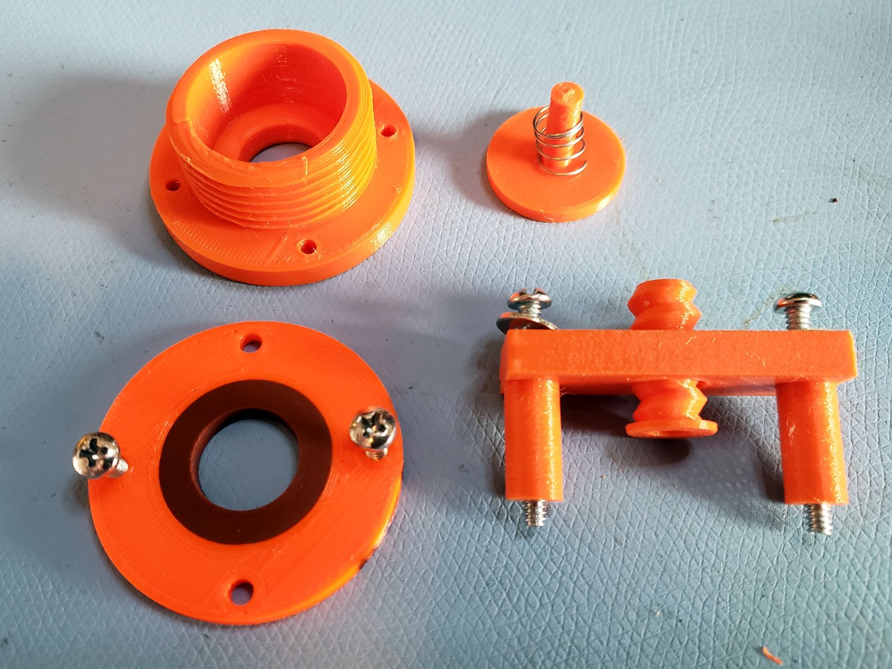

OP and PEEP Parts

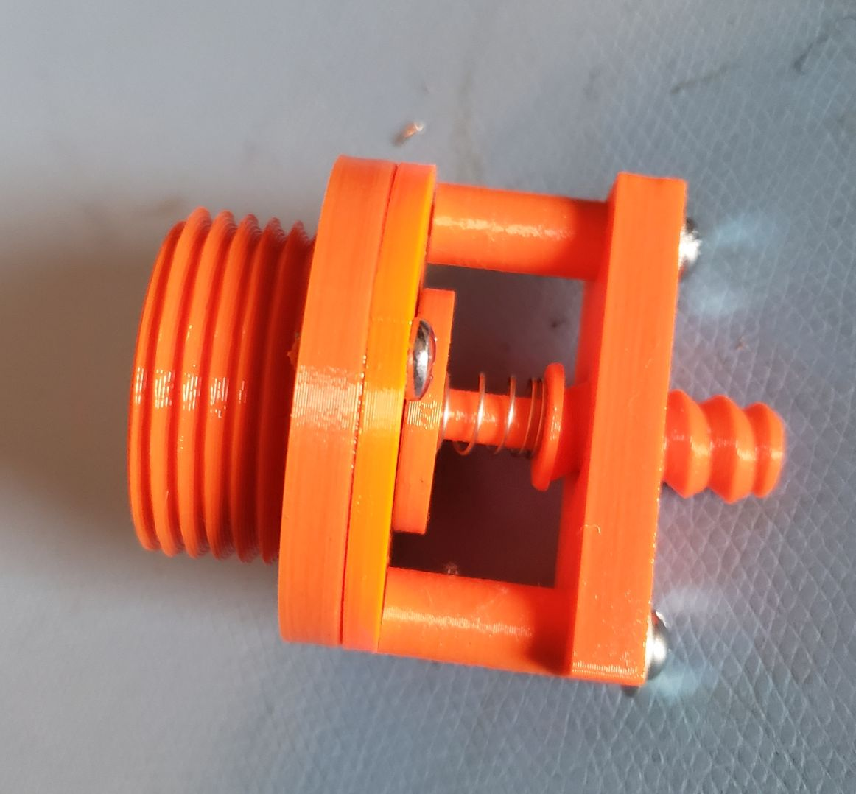

OP and PEEP Assembly

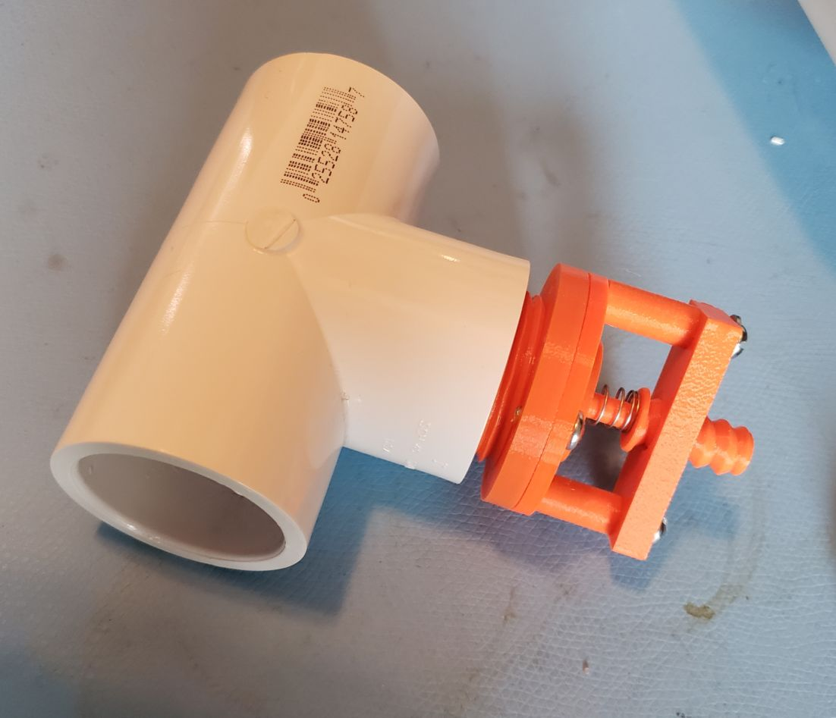

OP /PEEP Valve in T

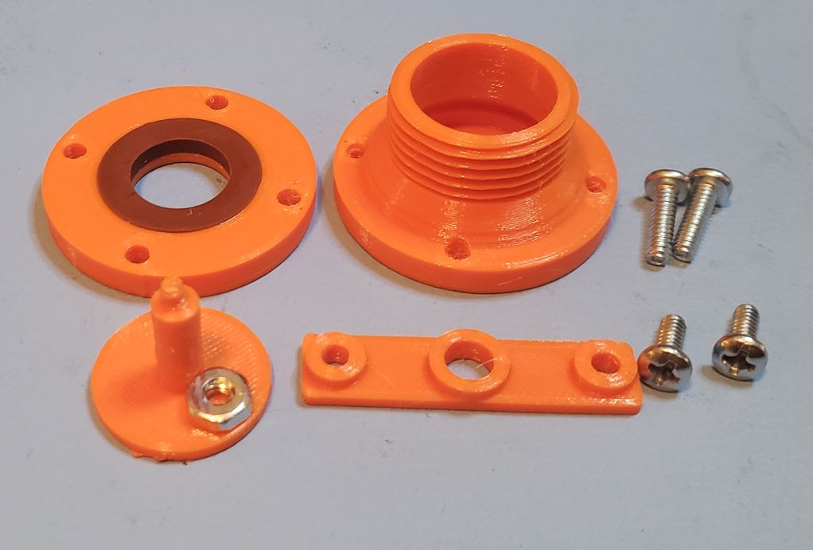

AA valve parts

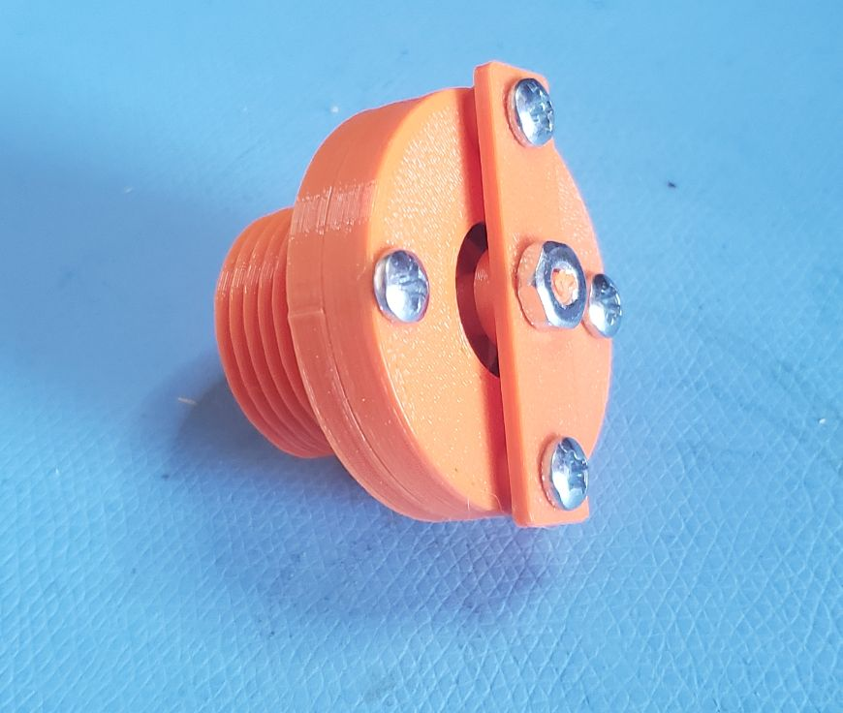

AA4 assembled